Read the attached PDF article about Ethical Considerations During Disaster.

Answer the following questions in a well-written paper:
Must answer all three questions.

- Which ethical approach do you think is the most useful for nurses when they plan for or deal with a natural disaster, and why did you select that approach?
- Discuss some ways nurses can prevent developing moral distress when their personal decision-making processes conflict with the processes that must be used during times of disaster.
- Discuss how the american nurses association (ANA) code of ethics provides guidance for nurses who respond to natural disaster.
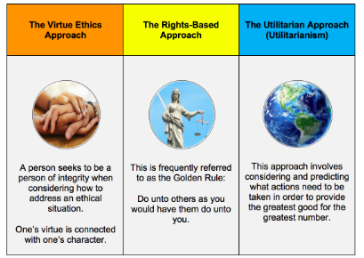
Look at the Code For Ethics PDF and use it!
Consider some of the ethical and legal aspects of disaster management.

-The paper should be 2–3 pages in length, not including the title page and references page
-Include an introduction and a conclusion to your paper
-APA format
-PLAGIARISM FREE

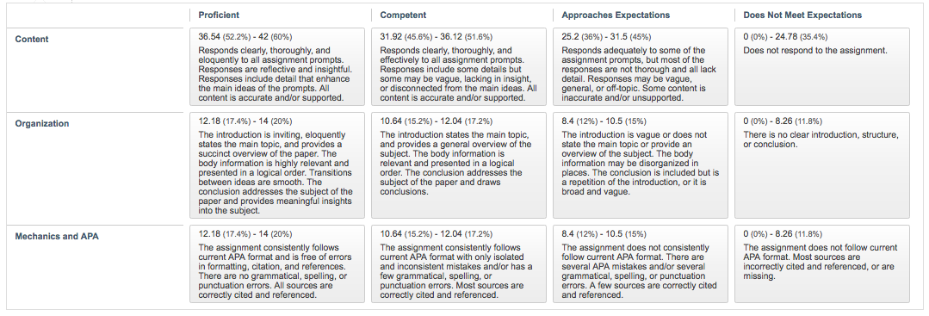
Follow the rubric:

